National Institute Of Technology Sikkim



Railway Route
Optimization System

Ashwani Kumar Dwivedi
B160137
under the guidance of:
Dr. Sangram Ray

Introduction

Objective :

Railway Route Optimization System is a product to serve to users who are tourists. The Main purpose of the project is to let the end users or passengers to know the shortest path to reach the destination with in short period and with amount as minimum as possible and as early as possible when more than one Railways route is to there to reach the destination.
The system will allow users to search for trains between any two stations on a given date.and to book the ticket on that particular date.
The Railways Route Optimization has 4 Modules
•Stations
•Trains
•Route
•Search

Stations module :
This module Maintains the data about station and allow operations like addition, deletion, modification. This module maintains stations tables and fields are station-id, station-name, and district, state. In this table Station-id, station-name is unique does not allow any unique values.
For arranging a route Starting station, ending station, via stations are must be registered in stations module, after registration of the stations administrator can arrange the path among that stations. This station module is handled by administrator only, can not handle end user

Trains module :
This module maintains the data about trains and allows operations like additions, deletion, and modification. The train module handles trains table and fields are train-id, train-name, starting-station, ending station, starting-time, ending-time, train-type.
In this train-id unique and this attribute does not allow any duplicate values

Route :
This module maintains the data about routes between stations and This module handle the routes tables and fields are route-id, starting-station, destination, timetakenforordinary, and timetakenforexpress. The module shows the graphical representation of a route between starting-station and destination.
This module is very useful to know routes between any two stations and also know shortest path among the routes, and also gives graphical representation of the corresponding routes

Search :
This module maintains the data about trains, routes tables and this module gives reports on trains and routes, this module
In this project has two active actors they are
1. Administrator
2.Traveller

Administrator :
The administrator has privileges on Databases he can Add data into these tables and allow all operations on these tables. Once data is stored into these tables after the traveler can send a query on that data for generating reports. And he can easily find out which is the shortest path between two stations

Traveler :
The traveler has only privileges on search for a train and a route and to reserve his seat in that train on a particular date.

Schedule :
Schedule contains the information of running times of different trains weekly.

Booking :
The booking database stores the booking information of all tickets reserved uptill now. The information is updated whenever a ticket is booked by any traveller.

Availability :
Contains the information of the availability of seats in every train on any date.

Passenger Name Record :
Every ticket booked has a unique Id associated with it called PNR.

Waiting List :
Whenever seats are not available in the train the booking information will go to the waiting list and the PNR status will be reffered to as waiting. Whenver a ticket is cancelled, the waiting list is traversed and the first booking PNR status will change to confirmed and the ticket will move to booking database.

Requirement Analysis and Inforrmation Gathering
- To test the system at every phase of coding we need a some on which we can test the progress we have made.
- I’ve created a railway network in which all nodes are mostly capitals of india and connected with imaginary railway routes.
- Initially I have created 41 trains to work in 83 different routes.
- The UI will give passenger a form through which he can choose source, destination and date of journey, and on submit the system will show all the trains between those stations on the given date along with the journey time of all trains and also the fare each train will have.
- Searching of trains can be done without logging in while to book ticket the user needs to be logged in.
- The passenger then will select the desired train and the desired class in which he wants his seat.
- Then passenger will enter his details and click confirm.
- Payment details will be taken from the traveller and the ticket will be issued with the generated PNR.
- Admin have the responsibility to maintain the databases.
- Admin will be given a UI through which he can alter the database.
- Admin can do following changes:
- Add new trains to database.
- Add new stations to database.
- Add new routes.
- Change the routes of trains.
- Refresh the database regularly.
- The database will be regularly refreshed by the Admin to allow new bookings.

Design

initial data map:

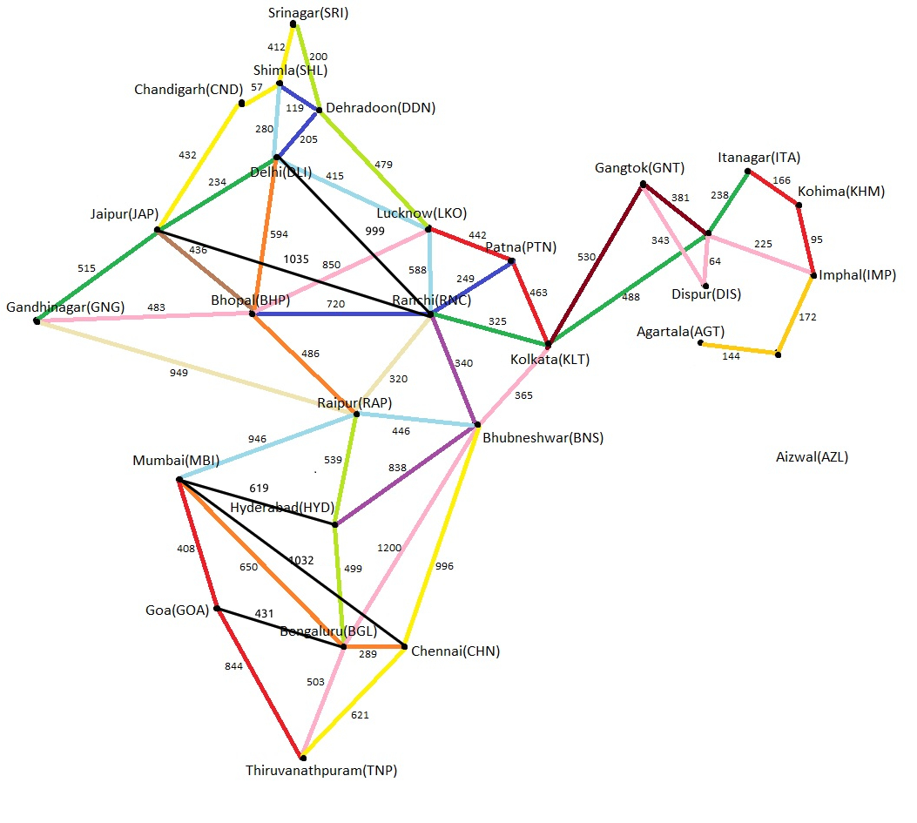

Use Case :
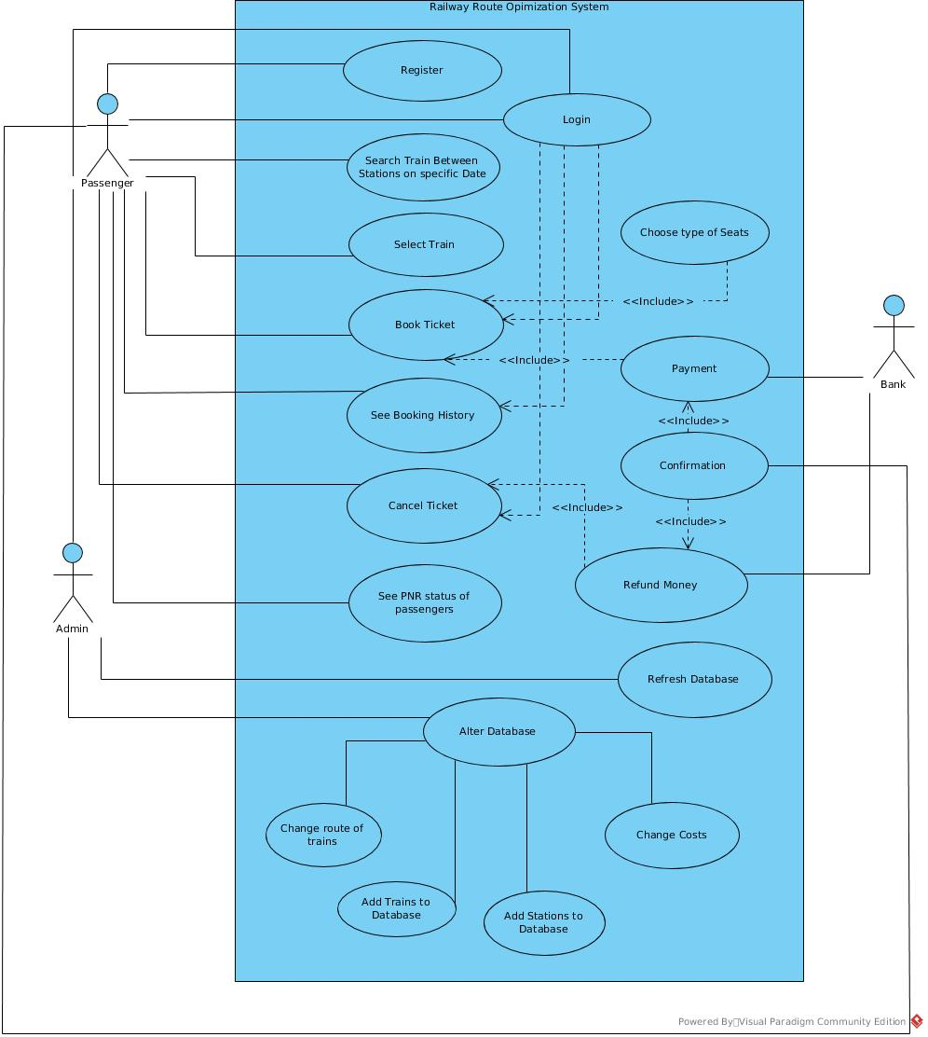

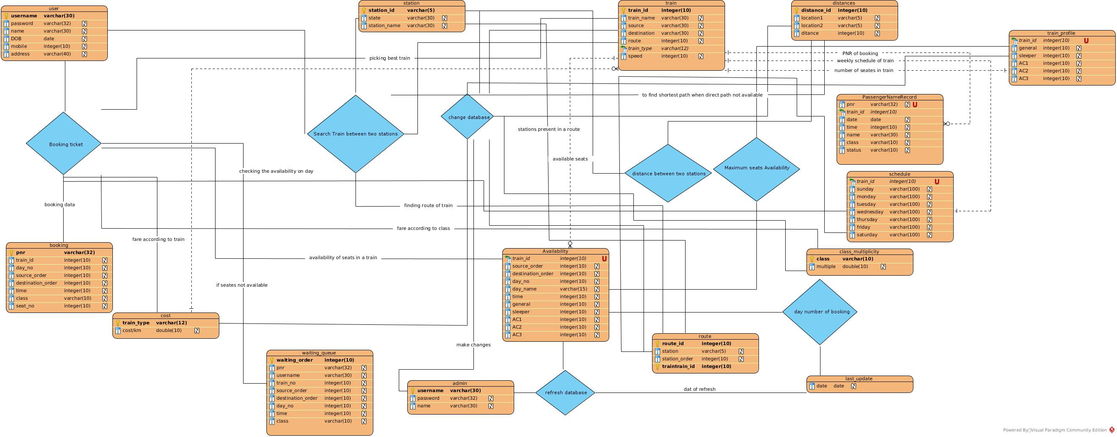
ER Diagram :

User Interface :
Home page:
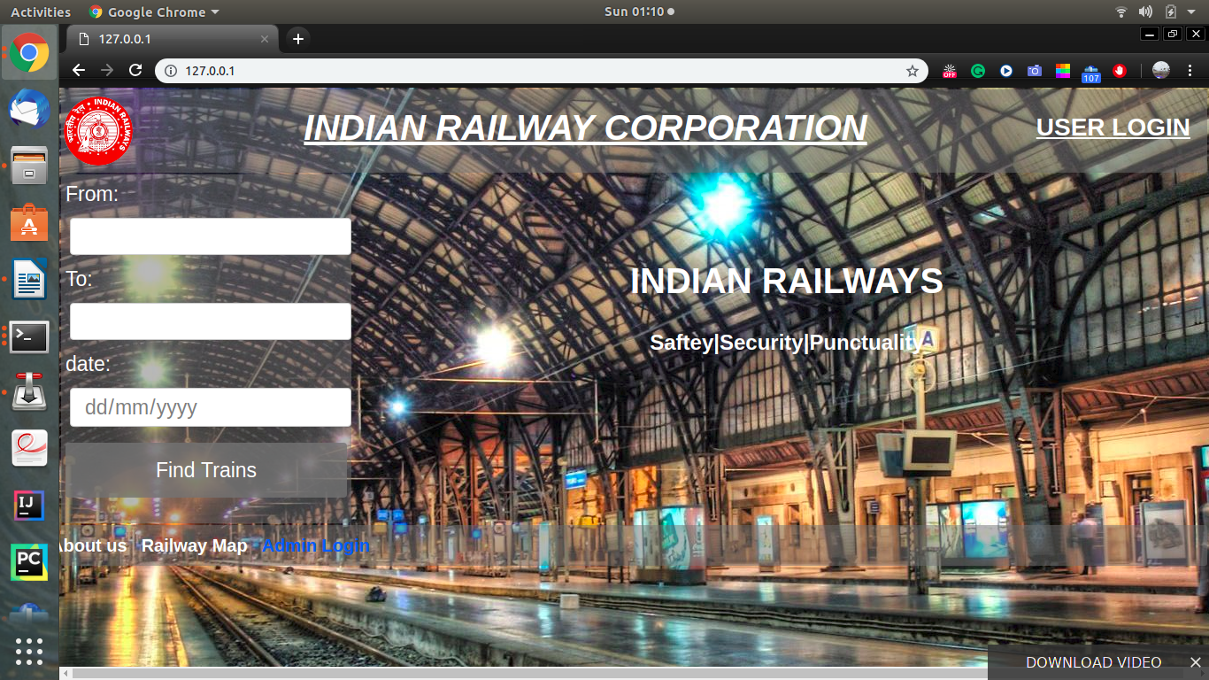
user login page:
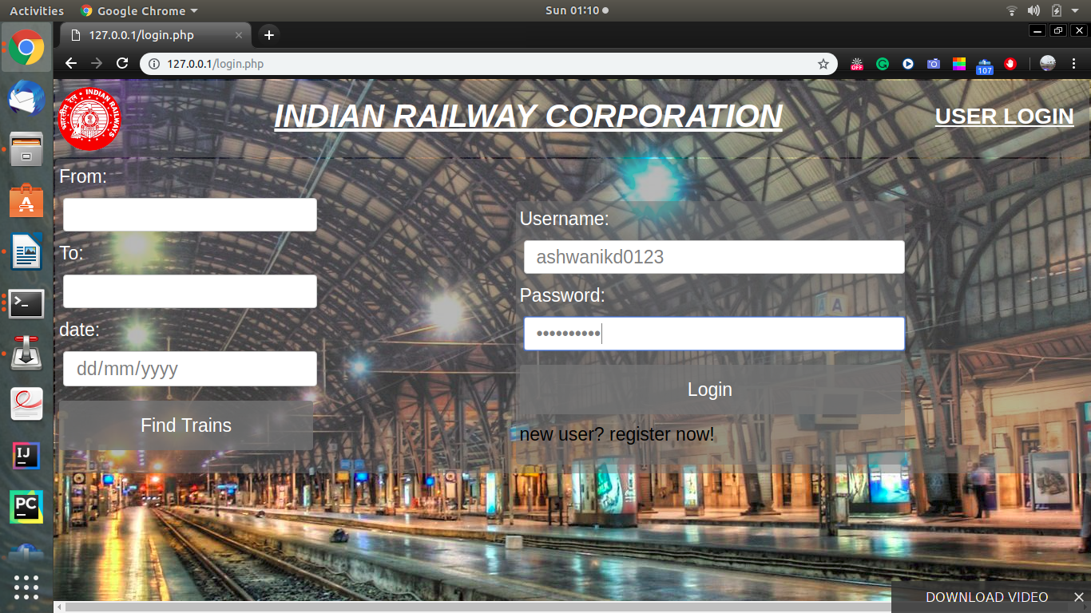
user dashboard page:

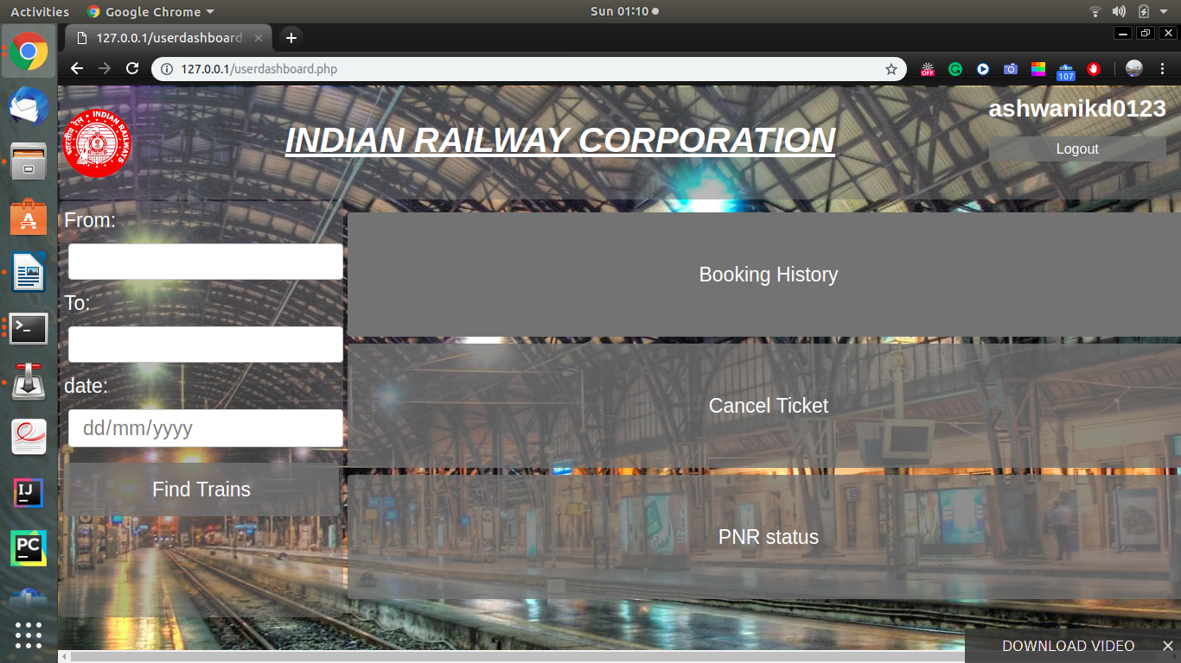
Booking History Page:
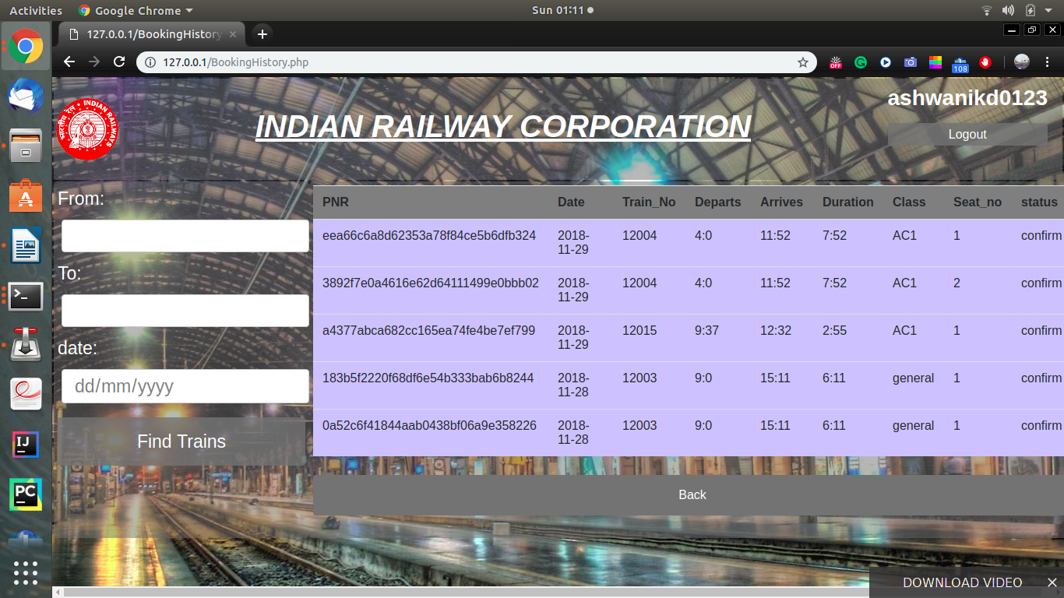

Search Result page:
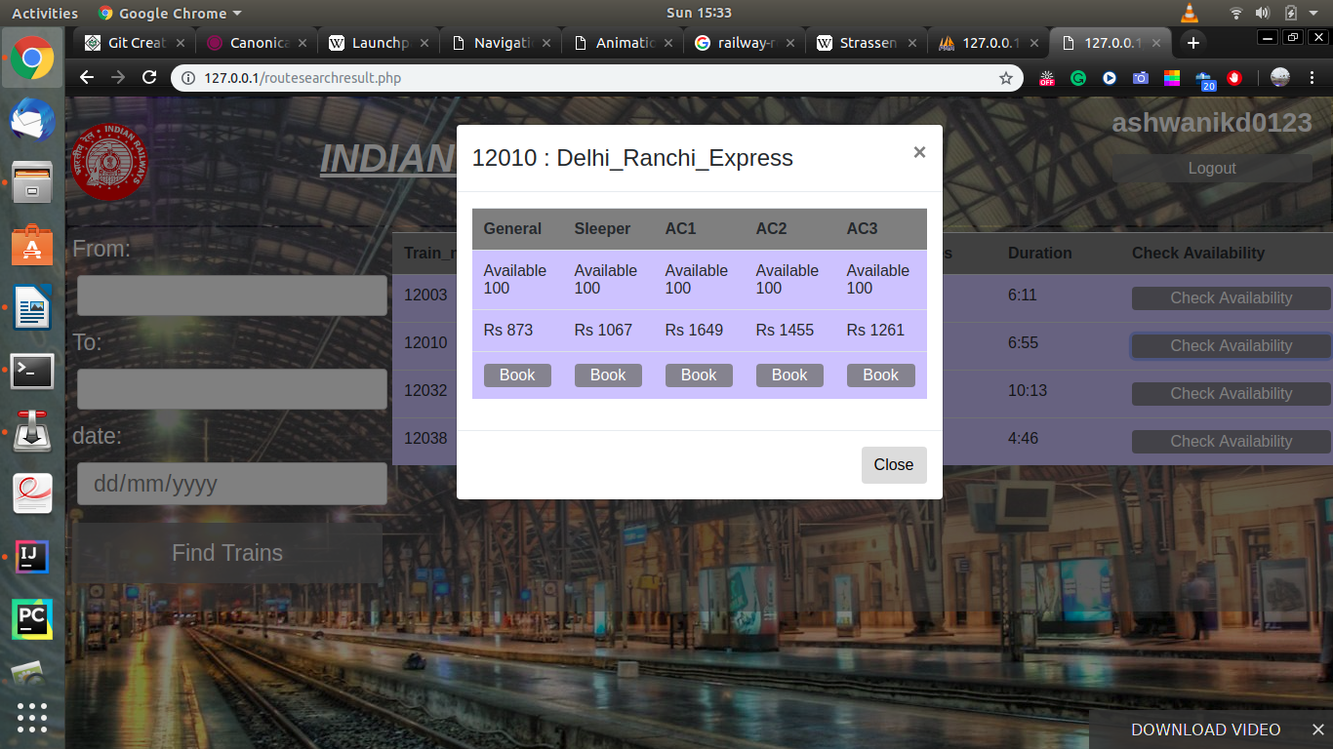
Search Result Page when no direct trains found:
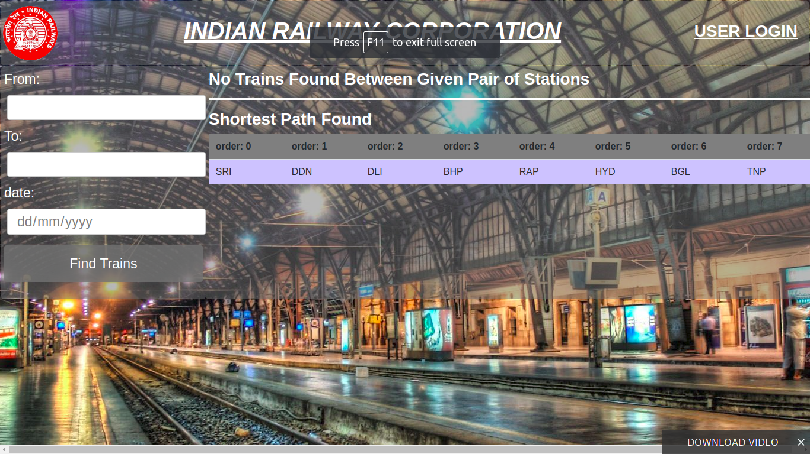

Booking Form:
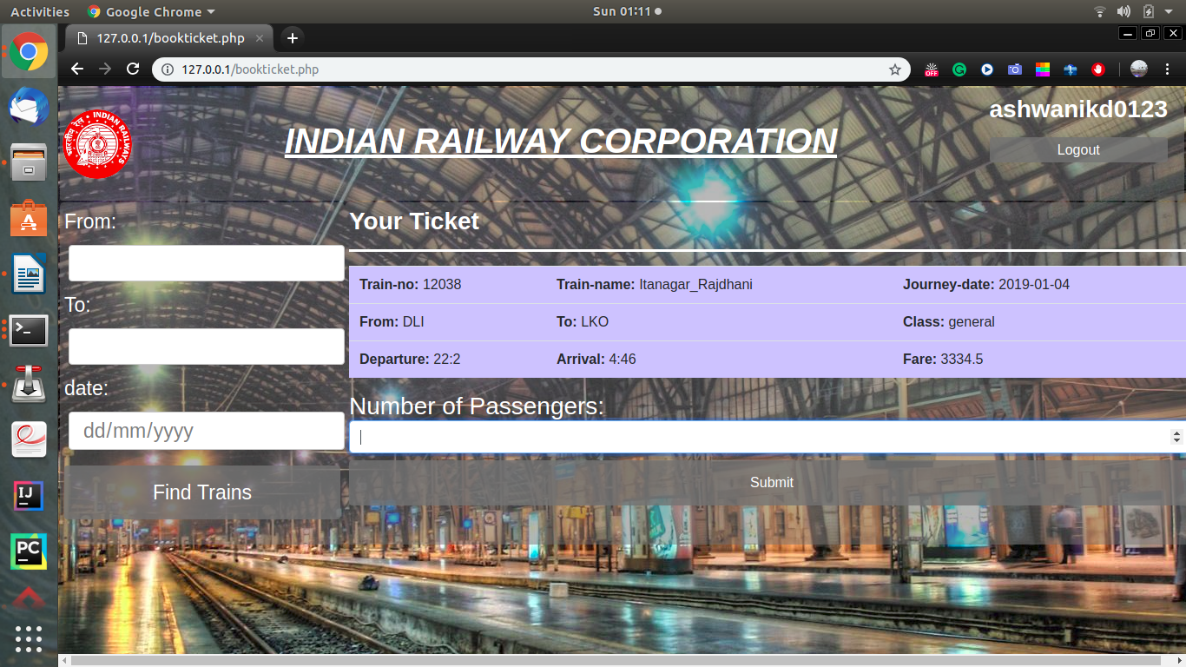
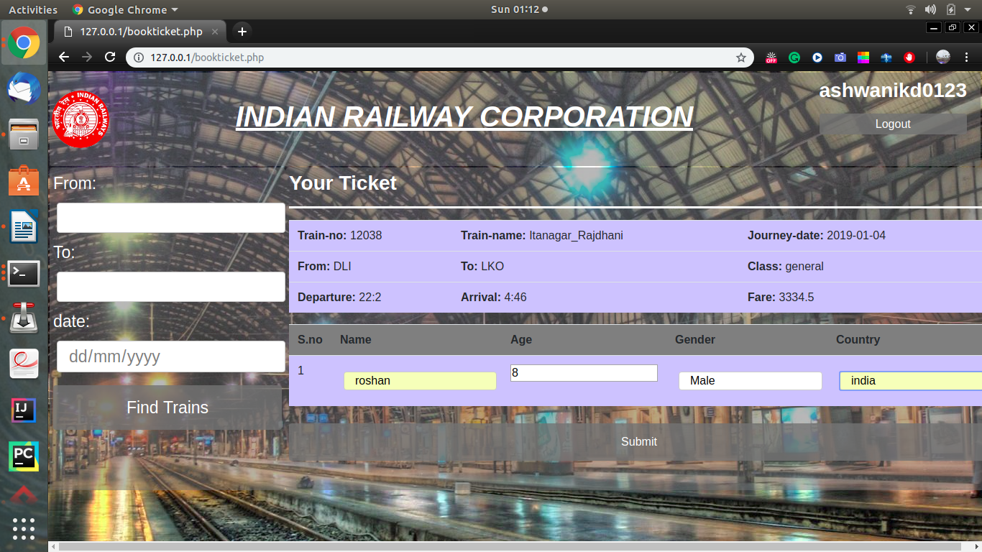

Booking Confirmation:
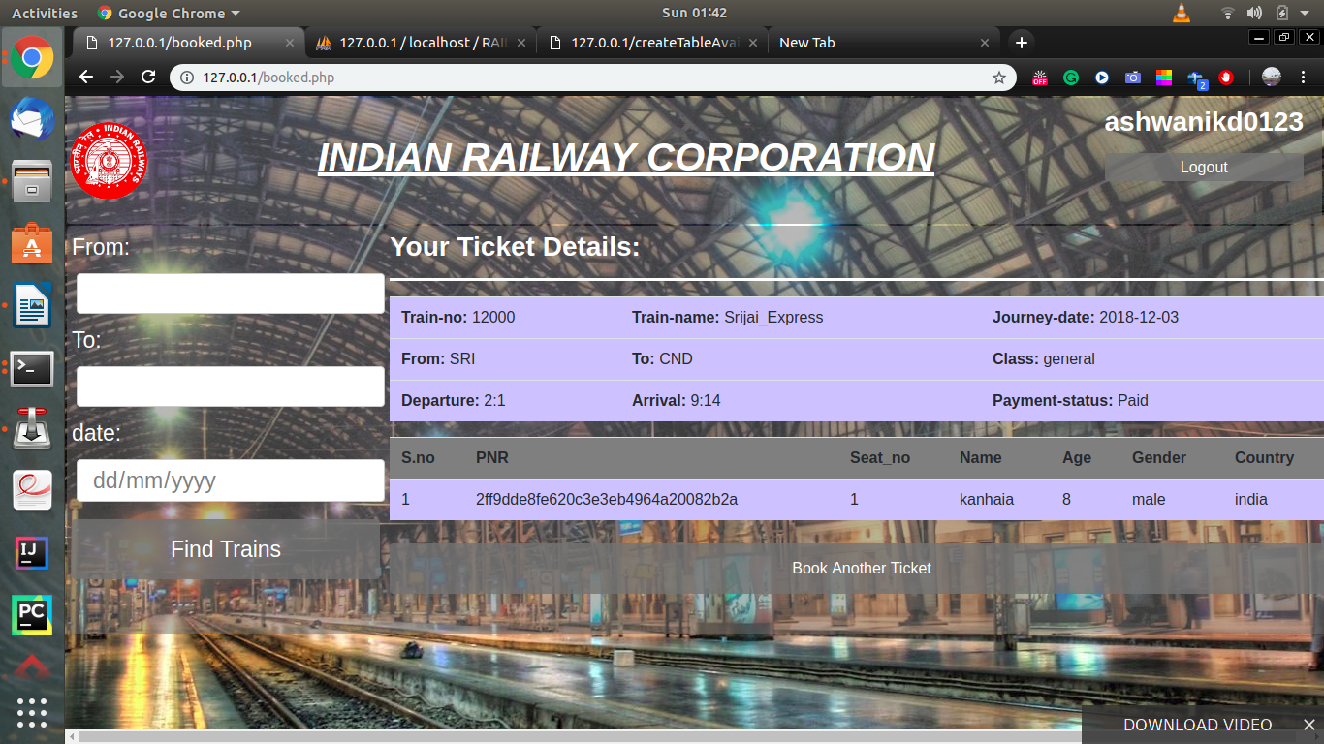

Admin Dashboard:
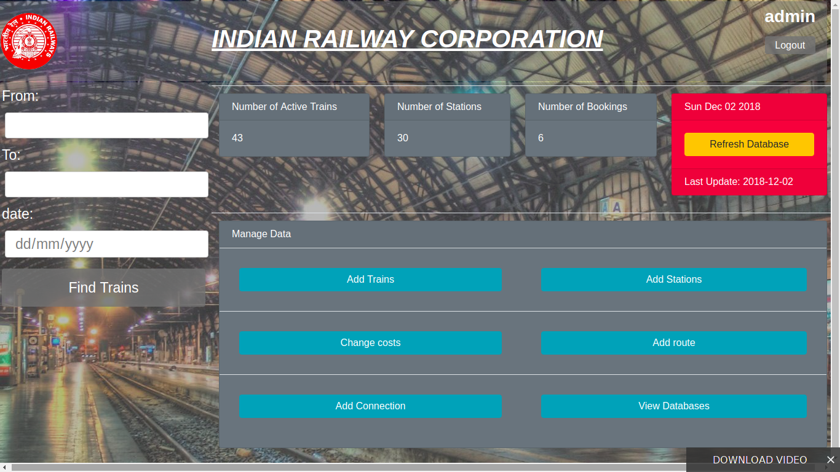

Implementation

Database Description:
Note: schemas of all databases are given in the ER diagram in design section
1. Trains
train database contains information about trains the route column contains the route Ids which that train follows and are stored in route database, train type which helps in deciding the cost of a journey, and speed of train which will later used in making the schedule of train.
2. Route
route database stores the route information. Every route have a unique route id and the route will have stations coming in a order.
e.g. to store a route A to B with route id 5 will be stored as
route_id | station_order | Station
5 | 0 | A
5 | 1 | B

3. Stations
station database contains the station names with their unique station Ids.
4. train_profile
it contains the information of maxmum seats present in the train. Columns general, sleeper, AC1, AC2, AC3 are the different classses user can pick to get the seat in.
5. distances
this contains the length of the railway path between any two stations in km.
6. schedule
it contains the schedule of every train.
In my case I’ve scheduled train for week, which the train will follow always.
Columns sunday,monday,... ,saturday contain the timing of departure, name of diffferent stations, order of station, and a flag to ndicate the train is going forward on route or backward.
Datas are seperated with # whild individual values are seperated by @
constraint: every train starts from 00:00 in forward route on sunday. Every train waits for 1 hour on every station.time is stored in number of seconds from 00:00 am of that day.
e.g. consider a schedule of train
train = 12005
sunday = JAP@0@0@0#BHP@34992@1@1#JAP@69984@0@2#
monday = BHP@18576@1@3#JAP@53568@0@4#
tuesday = BHP@2160@1@5#JAP@37152@0@6#BHP@72144@1@7#
wednesday = JAP@20736@0@8#BHP@55728@1@9#
thursday = JAP@4320@0@10#BHP@39312@1@11#JAP@74304@0@12#
friday = BHP@22896@1@13#JAP@57888@0@14#
saturday = BHP@6480@1@15#JAP@41472@0@16#
here train id is 12005
here format of individual data is
<station_id>@<dep_time>@<flag>@<station_order>
flag0: forward route(odd route id)
flag1: reverse route(even route id)
7. cost
it contains the cost we have per km for different types of trains.
8. class_multiplicity
multiplicity means a number that will be multiplied with the actual cost of journey according to the class of seat the user have choosen.
9. Availability
it contains the number of seats available for every possible booking in each train on each date upto next 40 days.
Creation of database availability
to create the database we need three tables train, schedule, train_profile.
Algorithm:
0. for day_no = 1:40
- load database train in variable T
- select first train t from T and remove it from T
- select p and s from train_profile and schedule where t.train_id = p.train_id and t.train_id = s.train_id
- variable merged = concat(s.sunday,s.monday , ... , s.saturday)
- let the route of train be x1->x2-> ... xn

- make a moore machine M like this
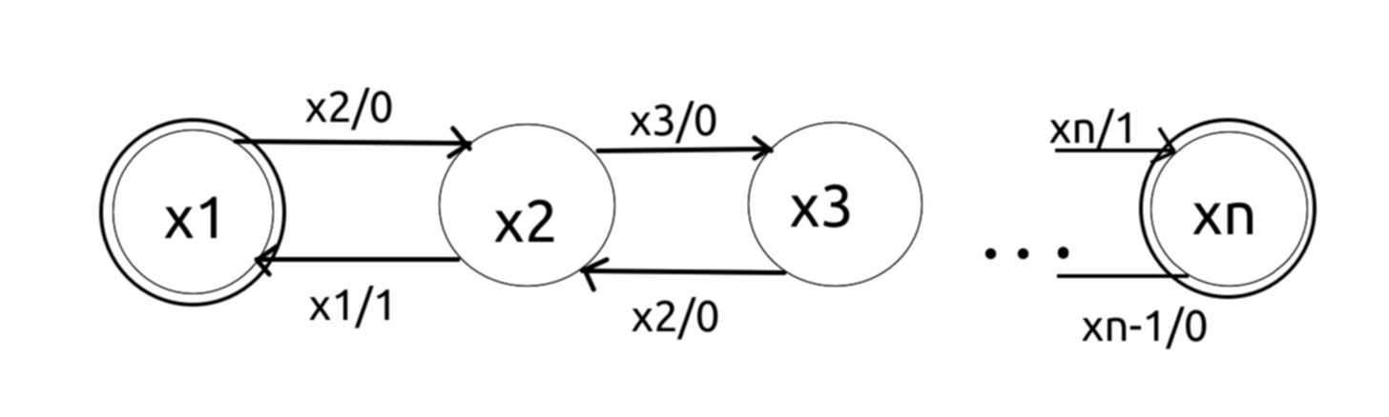

- array X = explode(‘#’,merged) //explode will break the string merged from every offset where # present
- for i=1:count(day(day_no)) //day() function gives weekdayname of //parameter
- x = explode(‘@’,day(day_no))
- make M initially at state x[‘station_id’]
- for j=i+1:count(x)
- y = explode(‘@’,X[j])
- if M.read(y[‘station_id’]) == 1
- break
- else
- Insert in Availability row source=x[‘station_order’] destination=y[‘station_order’] day_no = day_no and time = x[‘time’]
- end
- end
- if T is empty go to step 0 else goto step 1
- end

8. booking
this containsthe booking information of every booked ticket.
9. PassengerNameRecord
this contains the PNR status of every ticket.
10. waiting_list
this contains the information of tickets in waiting list. When a ticket is cancelled a ticket from waiting list will be moved to booking and its PNR will be made to confirm.

11. last_update
this contains the date of last refresh of Availability table.
12. user
contains the information of travellers booking ticket.
13. admin
contains information of administrator

Technology Used :
- php (server side scripting)
- MySql (RDBMS)
- HTML (making web pages)
- CSS (making webpages)
- XML (storing basic information of user)

What’s New :
generally railway reservation systems will not give any result whenever the user searches train between any two station which do ot have any direct trains between them, and hence user will have no clue for how to reach the destination e.g
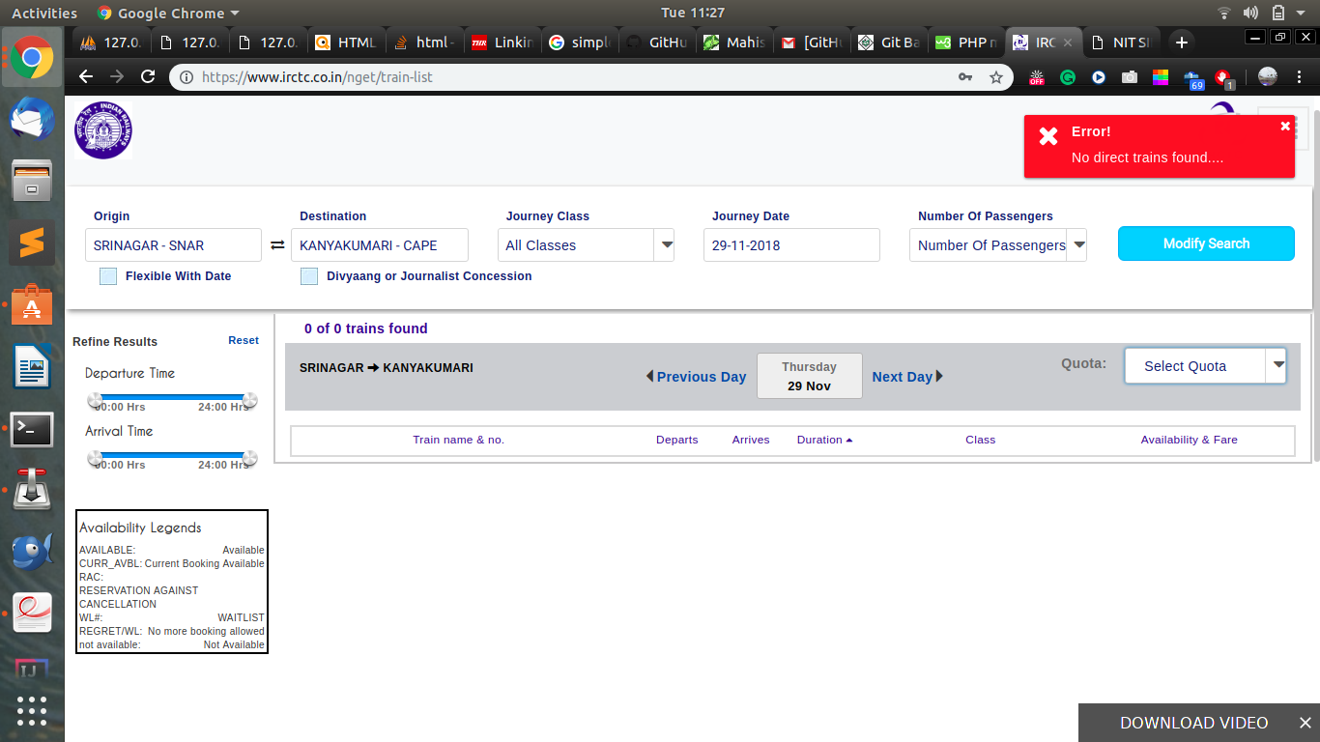

however we have overcome this problem. Our system on these type of searches will give a path from source to destination which are conected by some railway routes on which the user can search trains for reaching the destination.
this result is based on well famous Dijkstra’s Algorithm.

GithHub Link:
https://github.com/ashwanikd/Railway-Route-Optimization-System

